**R Code for Examples in the book**

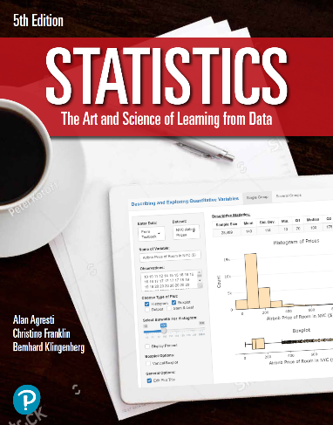

***“Statistics: The Art and Science of Learning from Data”***

**by Agresti, Franklin and Klingenberg, 5th edition**

**Chapter 2**

**Example 16: Cereal Sodium Data – Boxplot**

## Read in Sodium values:

sodium <- c(0, 340, 70, 140, 200, 180, 210, 150, 100, 130, 140, 180, 190, 160,290, 50, 220, 180, 200, 210)

## Basic Box Plot

boxplot(sodium, horizontal = TRUE,   
 main = 'Cereal Sodium Data',   
 xlab = 'Sodium (mg)')

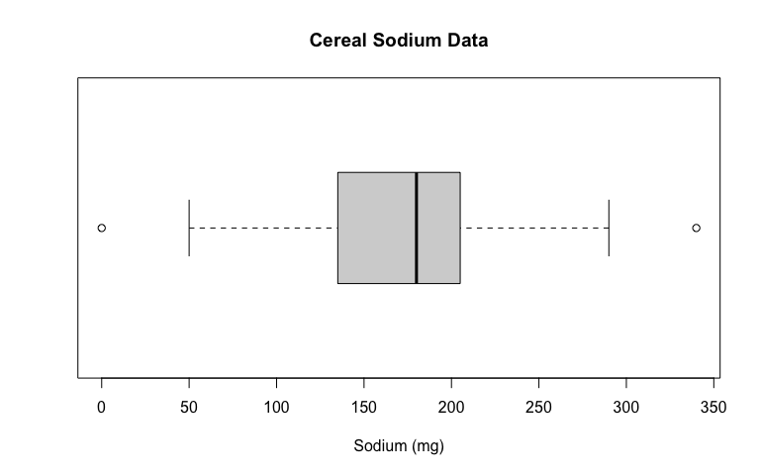

## A better-looking box plot can be obtained with the ggplot2 library. To install it, type install.packages('ggplot2').

library(ggplot2)  
ggplot(data.frame(sodium), aes(x='', y=sodium)) +   
 geom_boxplot(width = 0.3, fill = 'tan') +  
 coord_flip() +  
 labs(x = '', y = 'Sodium (mg)',   
 title = 'Box Plot of Cereal Sodium Data') +  
 theme_classic() +   
 scale_y_continuous(limits = c(-20,420),   
 breaks = seq(0,400,50),   
 expand = c(0,0)) +   
 theme(axis.line.y = element_blank(),  
 axis.text.y = element_blank(),  
 axis.ticks.y = element_blank(),  
 axis.title.y = element_blank()  
 )

